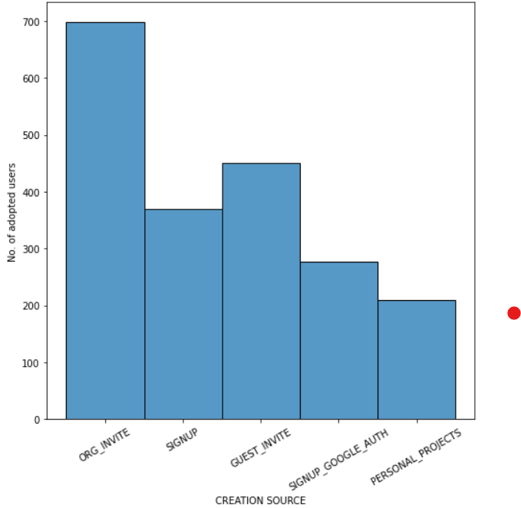ADOPTED USERS are more when they get a ORG_INVITE

Org having org id equals to 0 has more no of adopted users